**HOOPS General Summary**

For the UHC teams, we have been moving to the new Hours of Operation process (HOOPS) using the admin scripts in ICM with the lightspeed lookups to a database (dbsep5234cls “sherpa”).  On the business side they use the web interface to manage those skills (as we do as well to initially add the skills and hours): <https://svcvccworkintake.uhc.com/HOOPS>

Currently:

M&R – Fully 100% on HOOPS

E&I – Partially on HOOPS

C&S – Partially on HOOPS

**HOOPS General Troubleshooting**

Whenever there might be a complaint where a skill is not getting calls, one of the checks should always be to validate in the ICM routing script in the consider if to check if there is an OPEN flag check.  Generally they look like as examples: Global.userSH_N3_SK970_OPEN=1 or Global.userVCC_CHC_N1_SK1316_OPEN=1

**Method 1 of 3**

To validate which script the OPEN flag is set in, use the attached query which will search all open active scripts based on the variable name.  Note if you only use a skill #, be careful to look only for the full variable name as the same number could be on multiple variables and nodes.

If it’s a new HOOPS process, it will be in an admin script with a name like: ADM_N*_Hours* where the first asterisk is the node, second is sequence.  Ex: ADM_N1_Hours8.

In these scripts, the lightspeed lookup will be in on the far left, possibly multiple rows (usually up to 3).  Remember admin scripts run once every minute.  By monitoring, you can see if the lookups are working or not:

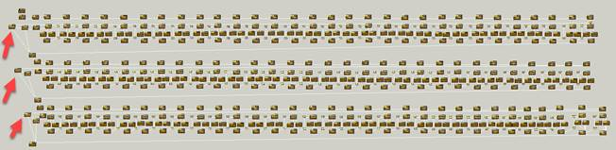

Zooming in and monitoring, here we can see there have been 446 lookups on this one Lightspeed lookup, 445 successful, 1 LS failure.  Of the 445 lookups that succeeded, all returned values (file populated).  Expectation here is that we have 100% success.  1 failure means for 1 minute we did NOT **update** the OPEN flags.  Typically not an issue if it runs the next minute successfully.  If it doesn’t update  the open flag will stay as it was set the last time it successfully ran.

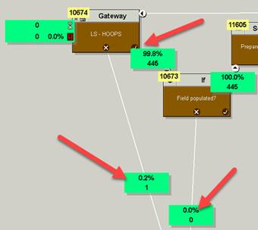

**Method 2 of 3**

Another way to check HOOPS is to run the LIGHTSpeed Exec Details sql query (attached). The ScriptType = ‘ICM’ and the Script Name = ‘ICM_ADM_HOOPS’.  Sample results look like this:

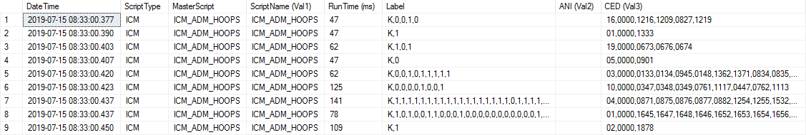

The run time should ALWAYS be less than 1500 ms (milliseconds), typically in double digit to low triple digits.  Also the Label column should ALWAYS return some value, starting with “K” meaning ok, followed by comma separated values, usually a 1 (Open), or 0 (Closed).  Can be other digits for holidays or special scenarios.  There should NEVER be a null value with ‘,,,,’.  If so that will throw off the OPEN flag settings.  That is a cause for alarm as well as blank values overall.  Note the values in the Label line up with the CED value with the list of skills.  K matches up with “0000”, then the rest go in order of the skills listed.

To have access to LIGHTSpeed, you will need access to dbsep5234cls “vcc_lightspeed”.  You can get this access if you don’t today by requesting access via Secure for the global group: [UHT_ICM](javascript:__doPostBack('fv_UserDetails$rptr_UserGroupMembership$ctl91$lbGrpName',''))

**Method 3 of 3**

There is a web report that Peter Breslin and the ICM platform team created that shows overall status of the HOOPS lookups (among all the different app gateway lookups in ICM).

That report is here: <http://apsep2060/ICM/>

Look for a section: ICM 2 Hours of Operation apsep03152\03154

Note PercentTimeouts and PercentUnavailable should be 0 ideally.  RequestsToHalf = 30 minute interal for all HOOPS LS lookups, in this example, 2520 lookups in a given timeframe (except that midnight half hour, likely overlap from previous minute)

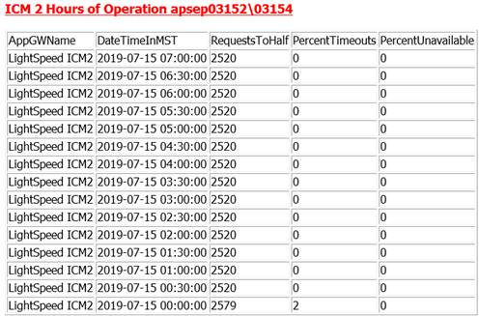

**HOOPS: If there is a problem**

**During business hours** – Open a P3 incident (or if one already open): add “CCS OMNI Platform Operations” as group owner.

Reach out directly to the following trained Omni Platform resources (Onshore first) via jabber or mobile:

|  |  |
| --- | --- |
| Shaf Abedin | 612-280-5990 |
| Pam Finlay | 925-978-7532 |
| Lin Song |  |
| Dennis Charette |  |
| Don Mills | 336-870-9086 |
| Harris Chasen | 352-777-0303 |
| Stephen Sundberg |  |
| Tony Puskarik |  |
| David Fitzpatrick | 353857881974 |
| Steve Asay |  |
| Rick Smith |  |
| Scott Urso |  |
| Anthony Villano |  |
| Vivek Gupta | 91 9820684486 |
| Pavan, S | 918050980260 |
| Ashok Govindasamy | 91 7760940880/  91 9788375772 |

If unable to reach these team members, call incident management (UHG HD 888-848-3375, option 8) to escalate to P2 and page: CCS OMNI Platform Operations + CCS_Delivery_ConversationManager-Dev

**Outside business hours** - Open a P3 incident (or if one already open): add “CCS OMNI Platform Operations” as group owner.

Reach out directly to the following trained Omni Platform resources (OGS first) via jabber or mobile:

|  |  |
| --- | --- |
| Vivek Gupta | 91 9820684486 |
| Pavan, S | 918050980260 |
| Ashok Govindasamy | 91 7760940880/  91 9788375772 |
| Shaf Abedin | 612-280-5990 |
| Pam Finlay | 925-978-7532 |
| Lin Song |  |
| Dennis Charette |  |
| Don Mills | 336-870-9086 |
| Harris Chasen | 352-777-0303 |
| Stephen Sundberg |  |
| Tony Puskarik |  |
| David Fitzpatrick | 353857881974 |
| Steve Asay |  |
| Rick Smith |  |
| Scott Urso |  |
| Anthony Villano |  |

If unable to reach these team members, call incident management (UHG HD 888-848-3375, option 8) to escalate to P2 and page: CCS OMNI Platform Operations + CCS_Delivery_ConversationManager-Dev

Additional Resources to engage as necessary:

|  |  |
| --- | --- |
| **Call Delivery - Paging** | CCS_Delivery_UHC_MnR  CCS_Delivery_UHC_EandI  CCS_Delivery_UHC_CAS |
| Betsy Sartori | 860-214-2636 |
| Ian Littman | 360-350-8408 |
| Jerome Geronimo | 639988411710 |
| Arra Discaya | 639988411701 |
| **Apps Dev - Paging** | CCS_Delivery_ConversationManager-Dev |
| Rohit Kher | 763-406-0958 |
| Surajit Bhattacharjee | 9963929080 |
| Shubam Awasthi | 91 7893856325 |
| **DBA - Paging** | CCS_Platform_DBAdmin |
| Kishore Adurty | 832-875-5474 |
| Rajesh Patel | 91 9986588892 |
| **Business Operations - Paging** | OmniChannel Leadership Paging Group |
| Laura Flaten | 320-420-0457 |
| Tom Barthel | 763-370-7014 |